# 📘 My English Hub

**English In Company – Enhance your staff with useful tools. Intermediate Level**

**📦 Logistics and Transport Sample Unit**

At the end of this unit, you will be able to...

* Understand and use vocabulary related to logistics and transport.
* Practice common dialogues used in logistics scenarios.
* Clearly explain delays, delivery issues, and tracking information.

Logistics is about **planning, organizing, and managing** how goods move from one place to another. People who work in logistics make sure that products arrive at the right place, at the right time, safely and efficiently.

This area includes:

* Transporting goods by trucks, ships, trains, or planes.
* Storing products in warehouses.
* Managing deliveries and shipments.
* Keeping track of goods from start to finish.

As customers, we often have logistics issues. For example, sometimes our orders arrive late, packages go missing, or products arrive damaged. Other times, we get the wrong items or can’t track our shipments. When this happens, we usually contact customer service to fix the problem.

Whether we work in logistics or we experience it as a customer, the following information will help us handle common situations, topic related.

Hands on!

**📌 Vocabulary Corner**

Study the following key logistics vocabulary:

| **Word/Phrase** | **Meaning / Explanation** |
| --- | --- |
| **shipment** | Goods sent from one place to another. |
| **freight** | Goods transported by truck, train, ship, or aircraft. |
| **warehouse** | Place where goods are stored before delivery. |
| **carrier** | Company responsible for transporting goods. |
| **consignment** | Goods sent at the same time to the same place. |
| **dispatch** | Sending off goods to their destination. |
| **lead time** | Time between placing an order and delivery. |
| **tracking** | Monitoring goods during transit. |
| **ETA (Estimated Time of Arrival)** | Expected arrival time of goods. |
| **delay** | Late arrival or departure of goods. |
| **inventory** | Complete list of goods held in stock. |

**Warm-up Questions**

* Have you ever faced problems when receiving or sending goods?
* How important is logistics in your business?
* What qualities should a good logistics service have?



**📌 Vocabulary Activity**

**A. Match the word to its definition:**

| **Words** | **Definitions** |
| --- | --- |
| 1. warehouse | ___ Goods sent together at one time |
| 2. dispatch | ___Sending goods to their destination. |
| 3. consignment | ___Complete list of items in stock. |
| 4. inventory | ___Place to store goods. |

**💬 Useful Phrases**

**Asking about a shipment:**

* “Could you give me an update on our shipment?”
* “Do you have tracking details for order number XYZ?”

**Reporting a delay:**

* “Unfortunately, there’s been a delay in dispatching your goods.”
* “We’re currently experiencing issues at the warehouse.”

**Confirming a delivery:**

* “Your consignment is scheduled for delivery tomorrow.”
* “The goods will arrive by 3 pm today.”

**🗣️ Dialogue Practice**

**Dialogue 1: Tracking Information**

Fill in the gaps with these words:

in transit - update - tracking

**A:** Good morning, ABC Logistics. How can I help you?  
**B:** Good morning. I’d like an ___________ on our shipment to Buenos Aires.  
**A:** Certainly. Could you provide your _____________ number?  
**B:** Yes, it’s 5648-ZX.  
**A:** Thanks. It’s currently ___ ___________ and expected to arrive by tomorrow afternoon.  
**B:** Great, thanks for the update.

**Dialogue 2: Delay Notification**

Fill in the gaps with these words:

delay - shipment - consignment

**A:** Hello, XYZ Transport.  
**B:** Hi, I’m calling regarding our _________________ scheduled for today.  
**A:** I'm sorry, but there’s been a slight _________ due to weather conditions. The _______________ will now arrive tomorrow morning.  
**B:** Understood. Thanks for letting us know.

**✅ Vocabulary Check**

Fill in the blanks with the correct vocabulary from today's lesson.

1. We store our products in the ___________ until they're ready for dispatch.
2. Could you contact the ____________ to ask about the delivery?
3. The ___________ left our warehouse yesterday and should arrive soon.
4. Before dispatching the goods, we need to check the ____________.

*(inventory, warehouse, carrier, consignment)*

**✍️ Speaking Task (Roleplay)**

Work in pairs. One person is the **Logistics Manager**, and the other is the **Client**. Roleplay this situation:

**Situation:**

The Client calls the Logistics Manager because their shipment hasn't arrived on the agreed date. The Logistics Manager needs to clearly explain the issue, apologize politely, and offer a new delivery date.

* **Client:** Express your concern clearly, ask specific questions.
* **Manager:** Clearly explain the issue, apologize professionally, and suggest a solution.

**Client:** Hello, this is Mark from ABC Company. *Our shipment was supposed to arrive today, but it hasn't arrived yet*. Can you tell me what happened?

**Manager:** Hi, Mark. I'm really sorry about that. *There was an issue at the warehouse that delayed your shipment.*

**Client:** I see. When can we expect it now?

**Manager:** It'll be delivered *tomorrow morning by 10 a.m*. Again, I apologize for the delay.

**Client:** Okay, thank you for letting me know.

**Manager:** You're welcome. Thanks for your understanding.

Here you have clear, simple examples:

### **Customer can say**:

1. **Our shipment arrived damaged.**
2. **We received the wrong items.**
3. **Our order arrived later than promised.**
4. **Some items are missing from our consignment.**
5. **The products we received don't match our purchase order.**

### **Logistics provider can say:**

1. **There was an error while processing your order.**
2. **The shipment was delayed due to bad weather.**
3. **The wrong items were mistakenly loaded onto the truck.**
4. **Unfortunately, the product codes were incorrectly entered into our system.**
5. **There was an unexpected issue at the warehouse.**
6. **We had problems with transportation.**
7. **There was a strike at the shipping port.**
8. **Your order was delayed because of customs procedures.**
9. **There was a labeling error at our warehouse.**
10. **We accidentally mixed your order with another customer's.**

**✏️ Practice Task: Create Your Dialogue**

With your partner, write your own short dialogue. Use vocabulary and useful phrases from this lesson.

**Scenario:**  
Your shipment hasn’t arrived on the expected date. Call the logistics company to find out what happened.

**A:** (Logistics company) ______________________________________  
**B:** (Customer) _____________________________________________  
**A:** ______________________________________________________  
**B:** ______________________________________________________  
**(Continue your dialogue)**

**🚚 Homework**

Write a short email (50-60 words) to inform your client about a delay in delivery due to a transportation strike.

* Include an apology and new estimated delivery time.
* Use some of the vocabulary and phrases learned today

Example:

**Subject:** *Update on your shipment – Delivery Delay*

Dear Mr. Johnson,

I’m writing to inform you *of a delay in your consignment due to a transportation strike*. We apologize for this inconvenience. Your shipment is now scheduled for delivery by *Thursday afternoon.* Please contact us if you need further assistance.

Kind regards,  
Chris Moore  
XYZ Logistics

Now, it's your turn...

🌟 **Great work today!**  
You're now better prepared to handle logistics issues in English!

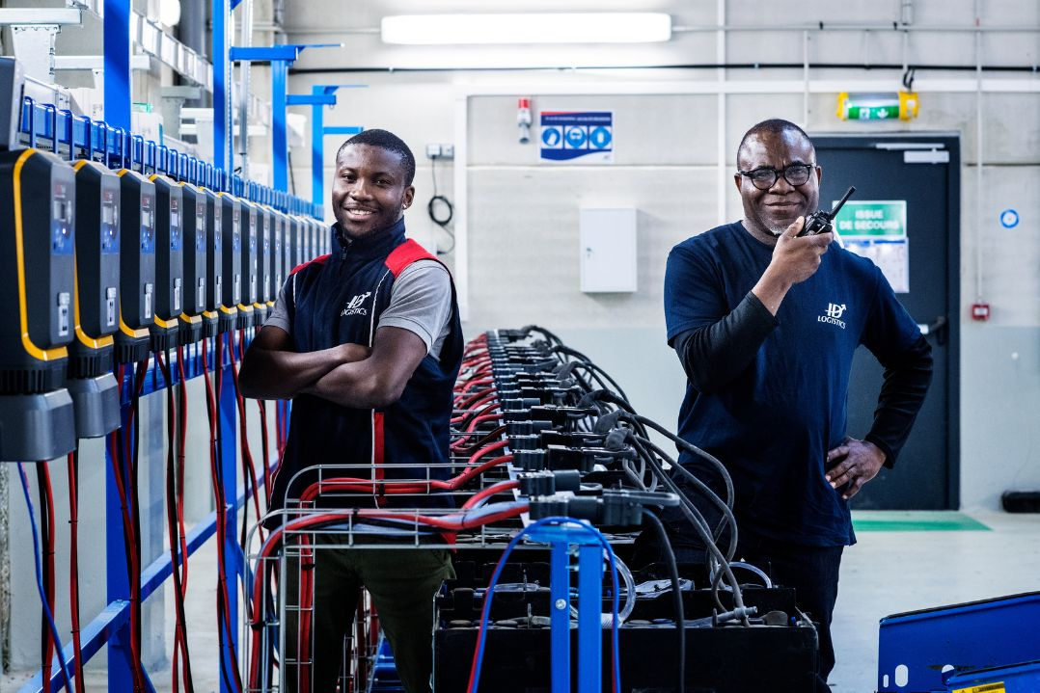

## 📲 Ready to level up even more?

👉 Join our weekly speaking challenges  
👉 Ask about our IELTs practice, English for Explorers or Professional English according to your activity.  
👉 My English Hub – where your voice becomes powerful